**PIXALPLAY**

**A MOVIE RECOMMENDER PLATFORM**

**PROJECT REPORT**

**(Frontend + Backend Development)**

***Submitted by***

**Hitesh Singla (2210993790)**



**BE-CSE (Artificial Intelligence)**

***Guided by***

**MR. VAISHNAV MURTADKAR**

**CHITKARA UNIVERSITY INSITUTE OF ENGINEERING & TECHNOLOGY**

**CHITKARA UNIVERSITY, RAJPURA**

**DECEMBER, 2024**

**TABLE OF CONTENTS**

1. **Acknowledgement………………..............                            3**
2. **Abstract………….……………….............                             4**
3. **Chapters:** 
   1. **Introduction…………………...                            5**
   2. **Problem Formulation…………                             6**
   3. **Proposed Solution……………..                            7**
   4. **Flowchart………..……………..                             8**
   5. **Software Requirements.………                             9**
   6. **Results…………....……………..                           10-13**
   7. **Conclusion….…....……………..                          14**
4. **References………………..………………..                            15**

**ACKNOWLEDGEMENTS**

With immense please , I **Hitesh Singla** (2210993790) are presenting the “**PixalPlay – A Movie Recommender Platform**” project report as a part of a curriculum of BE-CSE-AI.

Special thanks to our mentors **Mr. Vaishnav Murtadkar** for their valuable guidance, support, and insights in the successful completion of project.

I would also like to express my gratitude towards our dean **Dr. Sushil Narang** for giving us this great opportunity to do a project on “**PixalPlay – A Movie Recommender Platform**” .Without their support and suggestions, this project would not have been completed.

Signature………..

Name :- Hitesh Singla

Roll No. :- 2210993790

\

**ABSTRACT**

PixalPlay is an innovative movie recommendation platform designed to transform the way users discover and enjoy movies. Built using the MERN stack—comprising MongoDB, Express.js, React.js, and Node.js—PixalPlay offers a seamless and personalized experience through advanced AI-driven recommendations. The platform caters to a wide audience by suggesting movies based on user preferences, viewing history, and ratings, creating a tailored cinematic journey for every individual.

The frontend, developed using React.js, provides an intuitive and responsive user interface, ensuring smooth navigation across devices. The backend, powered by Node.js and Express.js, handles business logic and API requests, delivering data efficiently from the MongoDB database. A Python-based recommendation engine is integrated to analyze user behaviors and generate relevant suggestions through machine learning techniques like collaborative filtering and content-based filtering.

PixalPlay’s features include secure user authentication, movie search and browsing, watchlists, and user-generated reviews. Additionally, the platform highlights trending and popular movies to keep users updated. Administrators have access to a dedicated dashboard for managing content and monitoring user engagement.

The system is designed with scalability and security in mind, capable of supporting a growing user base without compromising performance. Future enhancements, such as integrating social features, developing a mobile app, and improving AI algorithms, aim to make PixalPlay a leading name in personalized entertainment.

By combining cutting-edge technology and user-focused design, PixalPlay redefines movie discovery, making it a valuable tool for cinephiles worldwide.

**3.1 INTRODUCTION**

Movies have become an integral part of modern entertainment, offering audiences a diverse range of genres, stories, and cinematic experiences. However, with the exponential growth of content available on various platforms, users often face the challenge of finding movies that align with their preferences. This challenge has created a demand for personalized movie recommendation systems that simplify the process of discovering content tailored to individual tastes. PixalPlay addresses this need by providing a modern and intelligent movie recommendation platform.

PixalPlay is built using the MERN stack, a popular technology stack comprising MongoDB, Express.js, React.js, and Node.js. This combination ensures a robust, scalable, and high-performing application capable of delivering an intuitive user experience. The platform is designed to analyze user preferences, viewing habits, and ratings using advanced machine learning algorithms, thereby offering personalized movie suggestions that resonate with individual interests.

The core functionalities of PixalPlay include secure user authentication, a vast repository of movies with detailed information, user reviews, ratings, and dynamic recommendations. The platform also features an admin dashboard to manage movie data and monitor user activities effectively. PixalPlay’s user-friendly interface ensures smooth navigation across devices, making it accessible to a diverse audience.

The project aims to bridge the gap between users and the overwhelming array of cinematic content available today. By leveraging state-of-the-art technology, PixalPlay not only enhances the user experience but also contributes to the evolving landscape of digital entertainment. This report provides an in-depth overview of the platform's design, implementation, and future possibilities, showcasing how PixalPlay redefines the way users explore and enjoy movies.

**3.2 PROBLEM FORMULATION**

In an era of abundant content, users face significant challenges in selecting movies that align with their interests. The vast amount of available media, combined with diverse preferences, creates a paradox of choice, often leaving users overwhelmed. Current solutions, such as generic trending lists or broad categorizations, fail to adequately address individual preferences, leading to suboptimal user satisfaction. This gap underscores the necessity for a platform that can effectively personalize movie recommendations.

The primary problem lies in understanding and predicting user preferences based on sparse and varied data, such as viewing history, user ratings, and implicit behaviors. Traditional recommendation systems often struggle with issues like cold-start problems (when a new user or movie has no prior data) and scalability when managing large datasets. Furthermore, maintaining a balance between accuracy and diversity in recommendations is crucial to avoid monotony in suggestions.

Another challenge is providing an engaging and seamless user experience across devices while ensuring secure handling of sensitive user data, such as login credentials and viewing habits. This necessitates a robust, scalable architecture capable of handling concurrent users without performance degradation.

PixalPlay aims to address these challenges by leveraging the MERN stack to create a high-performance, user-centric platform. By integrating advanced machine learning algorithms like collaborative filtering and content-based filtering, the system generates personalized recommendations tailored to each user’s unique preferences. The platform also incorporates user-friendly features, such as intuitive navigation, a rich movie database, and interactive tools like ratings and reviews, ensuring an engaging and secure environment for discovering content.

This formulation outlines the pressing need for a solution like PixalPlay, which merges cutting-edge technology with a focus on enhancing user satisfaction in the evolving entertainment landscape.

**3.3 PROPOSED SOLUTION**

PixalPlay presents a robust, user-focused movie recommendation platform designed to address the challenges of personalized content discovery. By leveraging the MERN stack—MongoDB, Express.js, React.js, and Node.js—PixalPlay offers a scalable, efficient, and secure system capable of meeting the diverse needs of modern users. The proposed solution incorporates advanced machine learning techniques and intuitive design principles to deliver a seamless experience.

**Core Features of the Solution**

1. **Latest Recommendations**: The platform integrates machine learning algorithms such as collaborative filtering and content-based filtering to analyze user preferences, ratings, and viewing history. This approach ensures highly relevant and diverse movie recommendations tailored to individual tastes.
2. **Rich Movie Repository**: PixalPlay hosts a comprehensive database of movies with detailed metadata, including genres, ratings, reviews, trailers, and cast information. This repository allows users to explore a vast array of options while making informed choices.
3. **User-Centric Interface**: The frontend, built with React.js, ensures a responsive and visually appealing user interface. Key features include dynamic movie browsing, easy search functionality, and a personalized dashboard for managing watchlists and preferences.
4. **Secure and Scalable Architecture**: With Node.js and Express.js powering the backend, PixalPlay offers a robust API for seamless communication between the frontend and database. MongoDB provides a scalable solution for storing and querying user data and movie metadata efficiently. Secure user authentication is implemented using JSON Web Tokens (JWT) and bcrypt for password hashing.
5. **Recommendation System Integration**: A Python-based recommendation engine is integrated with the backend using Flask. This allows real-time generation of personalized movie suggestions based on user activity and historical data.

**3.4 FLOWCHART**

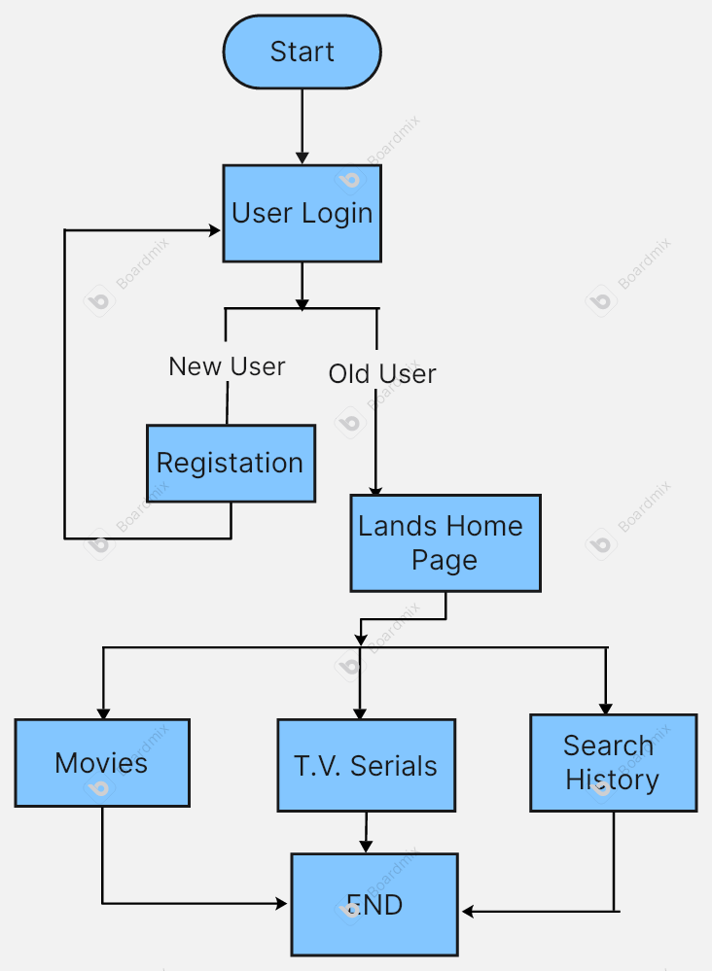

**Fig 4.1.**

**3.5 SOFTWARE AND HARDWARE REQUIREMENTS**

**Software Requirements:**

* **Operating System**: Windows, Linux, or macOS
* **Programming Language**:
  + **Frontend:** HTML, CSS, JavaScript (React.js).
  + **Backend:** Node.js
  + **Database:** MongoDB for storing hotel and booking data.
* **Development Tools:**
* **Visual Studio Code:** An IDE for writing and debugging code.
* **Postman:** For testing APIs.
* **Git:** For version control.
* **GitHub:** For code repository and collaboration.
* **Authentication & Security:**
* **JWT (JSON Web Tokens):** For user authentication and secure session handling.
* **Bcrypt:** For password hashing to enhance security.

**Hardware Requirements:**

* **Development Machine:**
  + Processor: Intel Core i5 or equivalent (or higher).
  + RAM: 2 GB (minimum), 8 GB (recommended for smoother performance).
  + Storage: 256 GB SSD or more for quick read/write operations.
* **Server**: A server to host the web application and manage databases
* **Network**: Internet connection for data transmission and reminders
* **Display**: For displaying the application interface

**3.6 RESULTS**



**Fig 6.1** – Landing Page without Authentication



**Fig 6.2 –** Sign-up Page

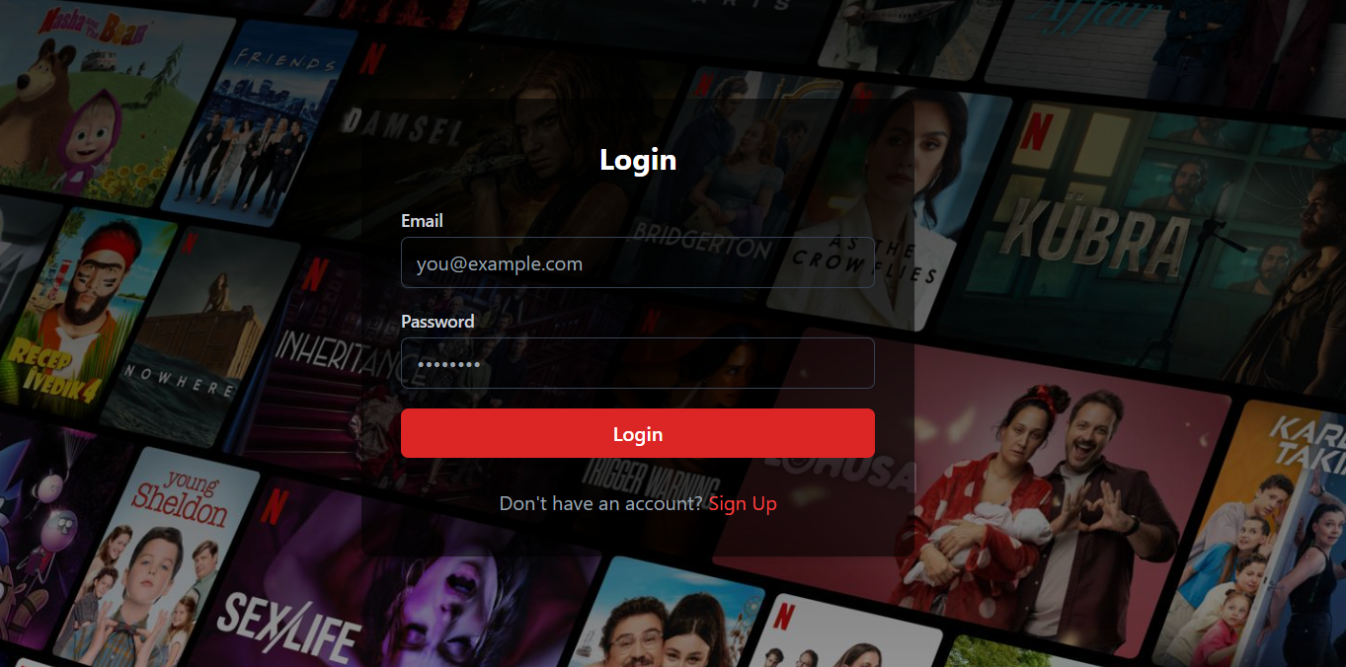

**Fig 6.3 –** Login Page



**Fig 6.4 –** Landing Page with Authentication (TV Shows)

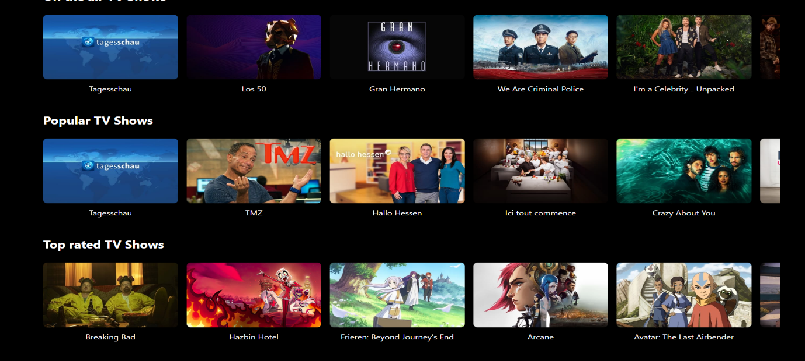

**Fig 6.7 -** Landing Page more TV shows



**Fig 6.6 -** Landing Page with Authentication (Movies)

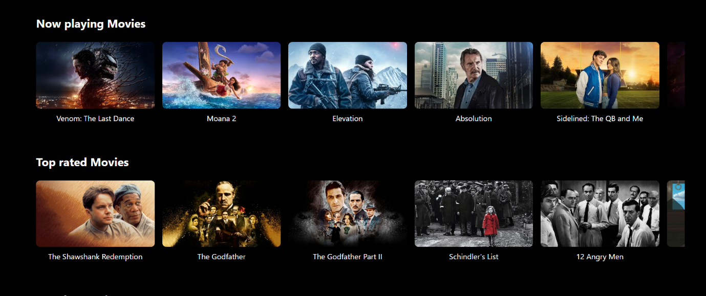

**Fig 6.7 -** Landing Page more Movies

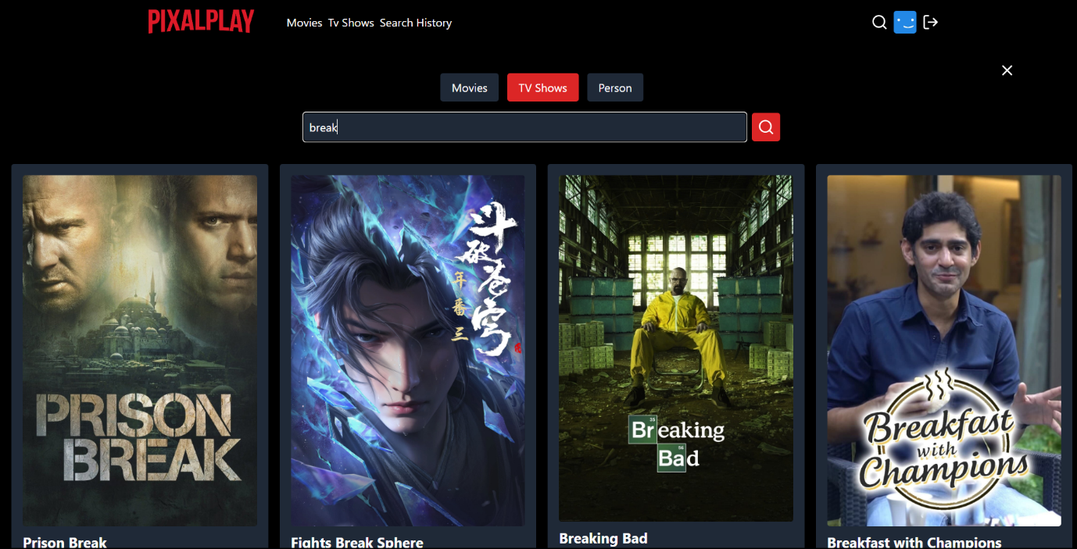

**Fig 6.7 –** Search Page (Movies)

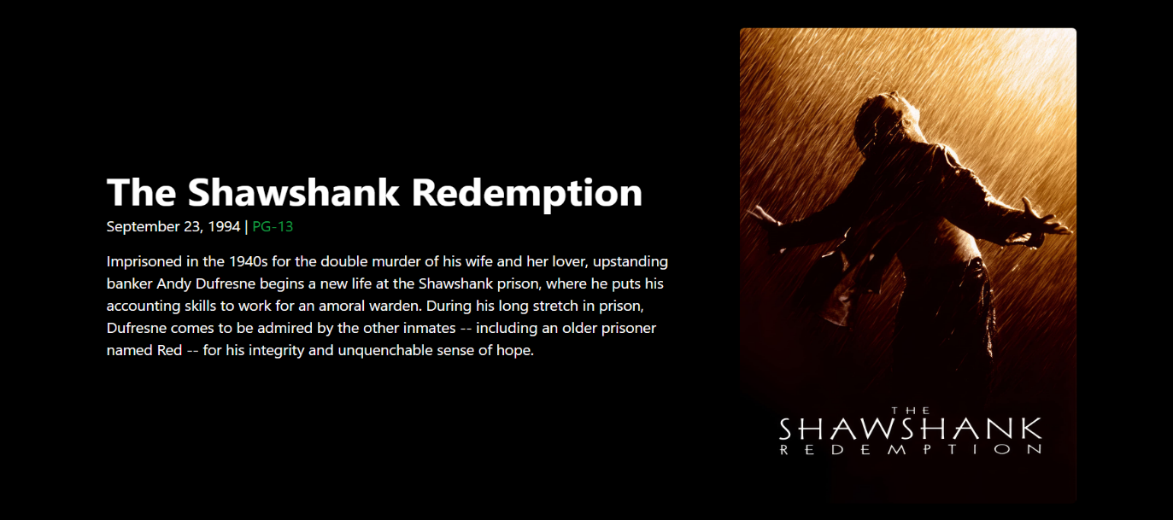

**Fig 6.8 –** Movies Details Page

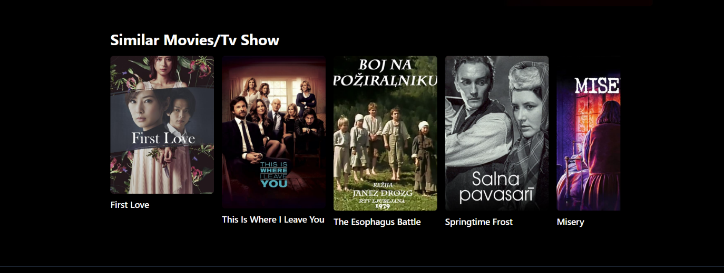

**Fig 6.9 –** Similar Movies Page

**3.7 CONCLUSION**

PixalPlay successfully addresses the growing challenge of personalized content discovery in the entertainment industry by leveraging cutting-edge technologies and user-centric design principles. Built on the MERN stack, the platform provides an efficient, scalable, and secure solution to help users navigate the overwhelming abundance of movies available today. Through its advanced recommendation system, PixalPlay tailors suggestions based on user preferences, ensuring an engaging and satisfying experience.

The platform’s robust architecture, featuring MongoDB for data management, React.js for a responsive frontend, and Node.js with Express.js for backend operations, ensures seamless performance. The integration of a Python-based recommendation engine further enhances the platform's ability to deliver accurate and diverse recommendations. Secure authentication mechanisms protect user data while maintaining a streamlined login and registration process.

PixalPlay’s intuitive interface and interactive features, such as ratings, reviews, and watchlists, enhance user engagement and encourage community interaction. For administrators, the platform provides tools to manage content and monitor user activity efficiently, ensuring a dynamic and well-maintained ecosystem.

By addressing common challenges such as the cold-start problem, data sparsity, and scalability, PixalPlay establishes itself as a comprehensive solution for personalized movie recommendations. Its adaptability allows for future enhancements, including social features, mobile application development, and multilingual support, ensuring relevance in a constantly evolving digital landscape.

In conclusion, PixalPlay is more than just a recommendation platform—it is a reimagined way for users to explore and enjoy cinema. By combining technology, design, and innovation, PixalPlay delivers an unparalleled movie discovery experience, setting a benchmark for similar platforms in the entertainment industry.

**REFERENCE**

* **MongoDB Documentation:** <https://www.mongodb.com/docs/>
  + Official MongoDB documentation for database design, queries, and scaling.
  + Cloud-based MongoDB database for easy deployment.
* **React.js Documentation:** https://reactjs.org/docs/getting-started.html
  + Detailed tutorials and best practices for developing with React.
* **Node.js Documentation:** https://nodejs.org/en/docs/
  + Comprehensive reference for building server-side applications with Node.js.
* **The Movie Database (TMDB):** <https://www.themoviedb.org/>
  + TMDB is a community-driven database offering comprehensive information about movies, TV shows, actors, and crew members. It provides APIs for developers to access movie data, including posters, trailers, and ratings, for use in applications.
* **Tailwind CSS:** <https://tailwindcss.com/>
  + Tailwind CSS is a utility-first CSS framework for rapidly building custom designs without leaving HTML. It’s highly flexible and optimized for modern web development.